**IGBT** **Module/IGBT** **模块**

# HSFF150R12F1GF1

**Features/特性**

* 1200V,150A
* 采用SPT+技术的低VCE(sat)

Low VCE(sat) with SPT+ technology

* 具有正温度系数的VCE(sat)

VCE(sat) with positive temperature coefficient

* 包括快速软恢复反并联前馈

Including fast & soft recovery anti-parallel FWD

* 高短路能力（10us）

High short circuit capability(10us)

* 低电感模块结构

Low inductance module structure

**Mechanical** **Features/机械特性**

绝缘的基板 Isolated Base Plate标准封装

Standard Housing

**Applications/应用**

**IGBT** **Power** **Module**

* 高频开关应用

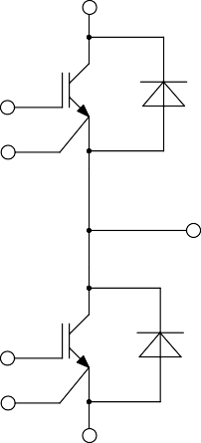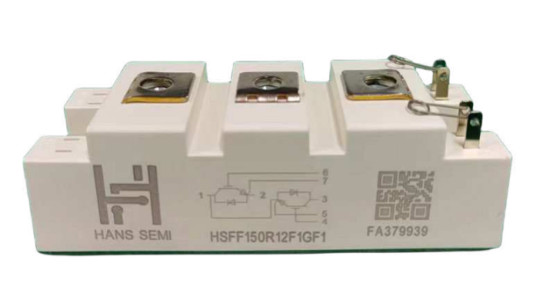

High Frequency Switching Application

* 电机驱动逆变器

Inverter for motor drive

* 交流和直流伺服驱动放大器

AC and DC servo drive amplifier

* 不间断电源

UPS (Uninterruptible Power Supplies)

* 软开关焊接机

Soft switching welding machine

* 光伏储能

Photovoltaic energy storage

**Equivalent** **Circuit** **Schematic/等效电路图**

# HSFF150R12F1GF1



**IGBT-Absolute** **Maximum** **Ratings** **(@** **TC** **=** **25°C** **unless** **otherwise** **specified)**

|  |  |  |  |  |
| --- | --- | --- | --- | --- |
| **Symbol** | **Parameter** | | **Value** | **Units** |
| VCES | Collector-Emitter Voltage  集电极-发射极电压 | | 1200 | V |
| VGES | Gate-Emitter Peak Voltage  栅极-发射极峰值电压 | | ±20 | V |
| IC | Continuous Collector Current  连续集电极直流电流 | TC = 100°C | 150 |  |
| ICM | Pulsed Collector Current  集电极重复峰值电流 | tp=1ms | 300 | A |
| Ptot | Total Power Dissipation  总功率功耗 | Tvj max = 150°C | 790 | W |

**IGBT** **Characteristics** **(@** **TC** **=** **25°C** **unless** **otherwise** **specified)**

|  |  |  |  |  |  |  |  |
| --- | --- | --- | --- | --- | --- | --- | --- |
| **Symbol** | **Parameter** | **Conditions** | | **Min.** | **Typ.** | **Max.** | **Unit** |
| VCE sat | Collector to Emitter Saturation Voltage  集电极-发射极饱和电压 | IC = 150 A, VGE = 15 V | Tvj=25℃ |  | 2.3 |  | V |
| Tvj=125℃ |  | 3.2 |  |  |
| VGE th | Gate-Emitter Threshold Voltage  栅极阈值电压 | IC = 1.0 mA, VCE = VGE, Tvj = 25°C | |  | 5.7 |  | V |
| ICES | Collector-Emitter Cut-off Current  集电极-发射机截止电流 | VCE = 1200 V, VGE = 0 V, Tvj = 25°C | |  |  | 1.0 | mA |
| IGES | Gate-emitter Leakage Current  栅极-发射极漏电流 | VCE = 0 V, VGE = 20 V, Tvj = 25°C | |  |  | 100.0 | nA |
| RGint | Internal Gate Resistor  内部栅极电阻 |  | |  | 1.0 |  | Ω |
| QG | Gate Charge  栅极电荷 | VGE=-15…+15V | |  | 0.8 |  | μC |
| Cies | Input Capacitance  输入电容 | VCE=25V,f=1MHz, VGE=0V | |  | 9.35 |  | nF |
| Cres | Reverse Transfer Capacitance  反向传输电容 |  | 0.35 |  | nF |
| tdon | Turn-on Delay Time  开通延迟时间 | VCE=600V,IC=150A, RG=5Ω,VGE=±15V | Tvj=25℃ |  | 39 |  | nS |
| Tvj=125℃ |  | 45 |  |
| tr | Rise Time  上升时间 | Tvj=25℃ |  | 55 |  | nS |
| Tvj=125℃ |  | 60 |  |
| tdoff | Turn-off Delay Time  关断延迟时间 | Tvj=25℃ |  | 134 |  | nS |
| Tvj=125℃ |  | 136 |  |
| tf | Fall Time  下降时间 | Tvj=25℃ |  | 89 |  | nS |
| Tvj=125℃ |  | 98 |  |
| Eon | Turn-On Switching Loss Per Pulse  开通损耗能量 | Tvj=25℃ |  | 4 |  | mJ |
| Tvj=125℃ |  | 8 |  |
| Eoff | Turn-off Energy Loss Per Pulse  关断损耗能量 | Tvj=25℃ |  | 14 |  | mJ |
| Tvj=125℃ |  | 15 |  |
| Isc | SC Data  短路数据 | VGE = 15 V, Vcc = 600V, tp ≤ 10 μs  VCEM ≤ 1200V, Tvj = 150℃ | |  | 480 |  | A |
| RthJC | Thermal Resistance,Junction to Case  结-外壳热阻 | per IGBT | |  |  | 0.19 | K/W |
| RthCH | Thermal Resistance,Case to Heatsink  外壳-散热器热阻 | per IGBT | |  | 0.081 |  | K/W |

**Diode-Absolute** **Maximum** **Ratings** **(@** **TC** **=** **25°C** **unless** **otherwise** **specified)**

# HSFF150R12F1GF1



|  |  |  |  |  |
| --- | --- | --- | --- | --- |
| **Symbol** | **Parameter** | | **Value** | **Units** |
| VRRM | Repetitive Peak Reverse Voltage  反向重复峰值电压 | | 1200 | V |
| IF | Diode Continuous Forward Current  连续正向直流电流 | | 150 |  |
| IFM | Diode Maximum Forward Current  正向重复峰值电流 | tp=1ms | 300 | A |

**Diode** **Characteristics** **(@** **TC** **=** **25°C** **unless** **otherwise** **specified)**

|  |  |  |  |  |  |  |  |
| --- | --- | --- | --- | --- | --- | --- | --- |
| **Symbol** | **Parameter** | **Conditions** | | **Min.** | **Typ.** | **Max.** | **Unit** |
| VF | Diode Forward Voltage  正向电压 | IC = 150 A | Tvj=25℃ |  | 1.9 |  | V |
| Tvj=125℃ |  | 2.0 |  |
| Qr | Recovered Charge  恢复电荷 |  | Tvj=25℃ |  | 17 |  | μC |
| Tvj=125℃ |  | 26 |  |
| Irm | Peak Reverse Recovery Current  反向恢复峰值电流 | IF = 150A, VR = 600 V, | Tvj=25℃ |  | 127 |  | A |
| Tvj=125℃ |  | 156 |  |
|  |  | - diF/dt = 1900A/μs, |  |
|  |  | Tvj=25℃ |  | 155 |  |  |
| trr | Reverse Recovery Time  反向恢复时间 | RG = 5 Ω, VGE = -15 V | nS |
| Tvj=125℃ |  | 375 |  |
| Erec | Reverse Recovery Energy  反向恢复损耗 |  | Tvj=25℃ |  | 8 |  | mJ |
| Tvj=125℃ |  | 12 |  |
| RthJC | Thermal Resistance,Junction to Case  结-外壳热阻 | per Diode | |  |  | 0.3 | K/W |
| RthCH | Thermal Resistance,Case to Heatsink  结-散热器热阻 | per Diode | |  | 0.1 |  | K/W |

# HSFF150R12F1GF1



**Module**

|  |  |  |  |  |  |  |
| --- | --- | --- | --- | --- | --- | --- |
| **Symbol** | **Parameter** | **Conditions** | **Min.** | **Typ.** | **Max.** | **Unit** |
| VISOL | Isolation Test Voltage  结缘测试电压 | RMS, f = 50 Hz, t = 1 min | 2500 |  |  | V |
| Tvj max | Maximum Junction Temperature  最大结温 |  |  |  | 150 | ℃ |
| Tvj op | Operating Junction Temperature  工作结温 |  | -40 |  | 150 | ℃ |
| TSTG | Storage Temperature Range  储存温度 |  | -40 |  | 125 | ℃ |
| RthCH | Case to Heatsink  外壳-散热器热阻 | per Module |  | 0.05 |  | K/W |
| Ms | Mounting Torque For Modul Mounting  模块安装的安装扭矩 | Recommended(M6) | 3 |  | 5 | Nm |
| Mt | Terminal Connection Torque  端子连接扭矩 | Recommended(M5) | 2.5 |  | 5 | Nm |
| G | Weight  重量 |  |  | 150 |  | g |

# HSFF150R12F1GF1

输🎧特性IGBT,逆变器（典型)

output characteristic IGBT,Inverter (typical) IC=f(VCE)

VGE=15V

输🎧特性IGBT,逆变器（典型)

output characteristic IGBT,Inverter (typical) IC=f(VCE)

Tvj=125°C

200

180

160

140

120

100

IC[A]

80

60

40

20

0

25℃

125℃

0 0.5 1 1.5 2 2.5 3 3.5 4 4.5 5

VCE[V]

200

180

160

140

120

100

IC[A]

80

60

40

20

0

VGE=9V VGE=11V VGE=13V VGE=15V VGE=17V VGE=19V

0 0.5 1 1.5 2 2.5 3 3.5 4 4.5 5 5.5 6 6.5 7

VCE[V]

传输特性IGBT,逆变器(典型)

transfer characteristic IGBT,Inverter(typical) IC=f(VGE)

VCE=20V

开关损耗IGBT,逆变器（典型) switching losses IGBT,Inverter(typical) Eon=f(RG),Eoff=f(RG) VGE=±15V,IC=150A,VCE=600V

200



180

160

140

120

100

IC[A]

80

60

40

20

0

25℃

125℃

5 8 11 14

VGE[V]

45

40 Eon,Tvj=25℃ Eoff,Tvj=25℃

35 Eon,Tvj=125℃

30 Eoff,Tvj=125℃

25

E[mJ]

20

15

10

5

0

0 5 10 15 20

RG[Ω]

# HSFF150R12F1GF1

瞬态热阻抗IGBT,逆变器

transient thermal impedance IGBT,Inverter ZthJC=f(t)

开关损耗二极管,逆变器（典型) switching losses Diode,Inverter(typical) Erec=f(RG)

IF=150A,VCE=600V

16

Erec,Tvj=25℃

14

Erec,Tvj=125℃

12

10

8

E[mJ]

6

4

2

0

0 5 10 15 20

RG[Ω]

正向偏压特性二极管,逆变器（典型)

forward characteristic of Diode, Inverter(typical) IF=f(VF)

瞬态热阻抗二极管,逆变器

transient thermal impedance Diode,Inverter ZthJC=f(t)

200

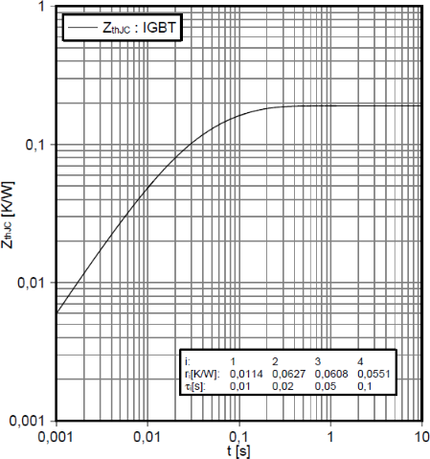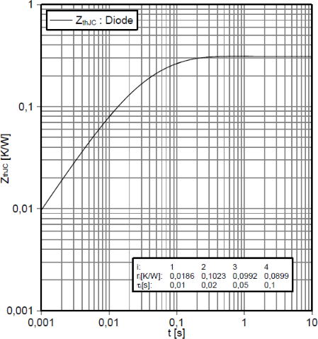

180

25℃

125℃

160

140

120

100

IF[A]

80

60

40

20

0

0 1 2 3 4

VF[V]

# HSFF150R12F1GF1

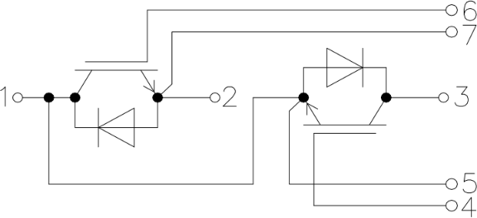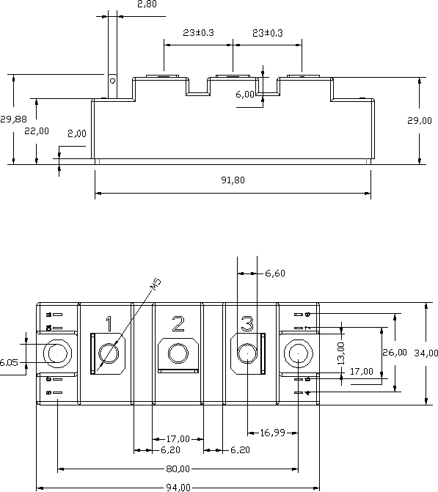

接线图**/circuit_diagram_headline**

封装尺寸/package outlines

6,3