HSG15N120LJ

IGBT

Features/特性

● 1200V，15A

● VCE(sat)(typ.)=2.0V @VGE=15V,IC=15A

● 具有正温度系数的VCE(sat)

VCE(sat) with positive temperature coefficient

● 包括快速软恢复反并联前馈

Including fast & soft recovery anti-parallel FWD

● 快开关速度

High speed switching

Applications/应用

● 不间断电源

Uninterruptible power supply

● 电机驱动逆变器

Inverter for motor drive

● 交、直流伺服驱动放大器

AC and DC servo drive amplifier

Equivalent Circuit Schematic/等效电路图

HansSemicon.cn

1

Preliminary Datasheet

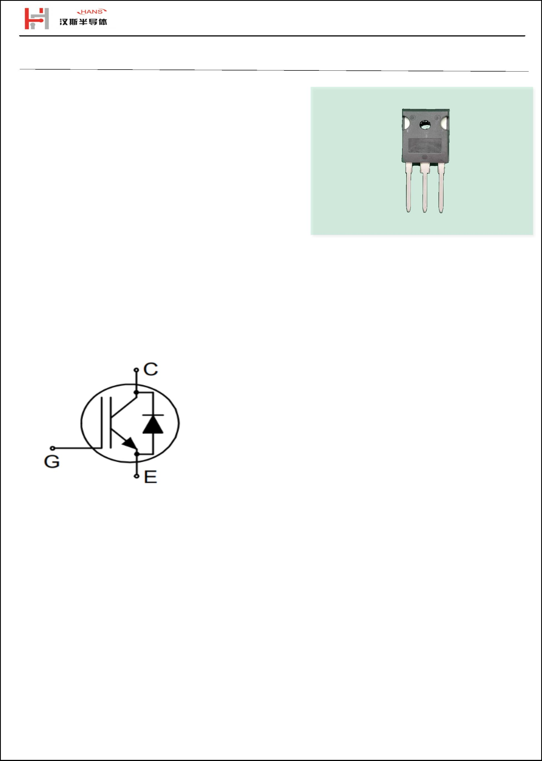

HSG15N120LJ

IGBT-Absolute Maximum Ratings (@ T = 25°C unless otherwise specified)

C

Symbol

VCES

Parameter

Value

1200

±30

Units

Collector-Emitter Voltage

集电极-发射极电压

Gate-Emitter Peak Voltage

栅极-发射极峰值电压

V

V

VGES

DC collector current, limited by Tvjmax

集电极直流电流受最大结温限制

IC

T = 100°C

C

15

45

Α

Pulsed collector current, tp limited by Tvjmax

集电极脉冲电流脉宽受最大结温限制

ICM

A

T = 25°C

108

43

W

W

C

Maximum Power Dissipation

最大耗散功率

Ptot

T = 100°C

C

IGBT Characteristics (@ T = 25°C unless otherwise specified)

C

Symbol

Parameter

Conditions

Min.

Typ.

2.0

Max.

2.5

Unit

V

Collector to Emitter Saturation Voltage

集电极-发射极饱和电压

VCE sat

IC = 15 A, VGE = 15 V

Gate-Emitter Threshold Voltage

栅极阈值电压

VGE th

ICES

IGES

QG

IC = 250 uA, VCE = VGE

4.5

5.2

6.5

V

Collector-Emitter Cut-off Current

集电极-发射机截止电流

VCE = 1200 V, VGE = 0 V, Tvj = 25°C

VCE = 0 V, VGE = ±30 V, Tvj = 25°C

100.0

±100

uA

nA

nC

nC

nC

nF

nF

nF

nS

nS

nS

nS

mJ

mJ

Gate-emitter Leakage Current

栅极-发射极漏电流

Gate Charge

栅极电荷

120

50

Gate-Emitter Charge

栅极-发射极电荷

V =600V,I =15A

CC

C

QGE

QGC

Cies

Coies

Cres

tdon

tr

V =15V

GE

Gate-Collector Charge

栅极-集电极电荷

15

Input Capacitance

输入电容

2450

95

Output Capacitance

输出电容

V =25V,f=1MHz,

CE

V =0V

GE

Reverse Transfer Capacitance

反向传输电容

45

Turn-on Delay Time

开通延迟时间

37

Rise Time

上升时间

74

Turn-off Delay Time

关断延迟时间

tdoff

tf

V =600V,I =15A,

83

CE

C

R =15Ω,V =15V

G

GE

Fall Time

下降时间

93

Turn-On Switching Loss Per Pulse

开通损耗能量

Eon

Eoff

1.24

0.48

Turn-off Energy Loss Per Pulse

关断损耗能量

HansSemicon.cn

2

Preliminary Datasheet



HSG15N120LJ

Diode-Absolute Maximum Ratings (@ T = 25°C unless otherwise specified)

C

Symbol

VRRM

IF

Parameter

Value

1200

15

Units

Repetitive Peak Reverse Voltage

反向重复峰值电压

V

Α

A

Diode Continuous Forward Current

连续正向直流电流

T = 100°C

C

Diode maximum current, tp limited by Tvjmax

二极管最大电流，脉宽受最大结温限制

IFM

45

Diode Characteristics (@ T = 25°C unless otherwise specified)

C

Symbol

Parameter

Diode Forward Voltage

Conditions

Min.

Typ.

Max.

Unit

VF

IF = 15 A

2.1

3.5

V

正向电压

Recovered Charge

恢复电荷

Qrr

Irr

470

15

nC

A

Peak Reverse Recovery Current

反向恢复峰值电流

IF = 15A, VCE = 600 V,

R =15 Ω

G

Reverse Recovery Time

反向恢复时间

trr

62

nS

Thermal Characteristics

Symbol

Parameter

Thermal resistance, junction to case for IGBT

IGBT 结-外壳热阻

Min.

Typ.

Max.

Unit

RthJC

RthJC

RthJA

1.2

℃/W

Thermal resistance, junction to case for Diode

二极管 结-外壳热阻

℃/W

℃/W

1.5

40

Thermal resistance, junction to Ambient

结-环境热阻

HansSemicon.cn

3

Preliminary Datasheet

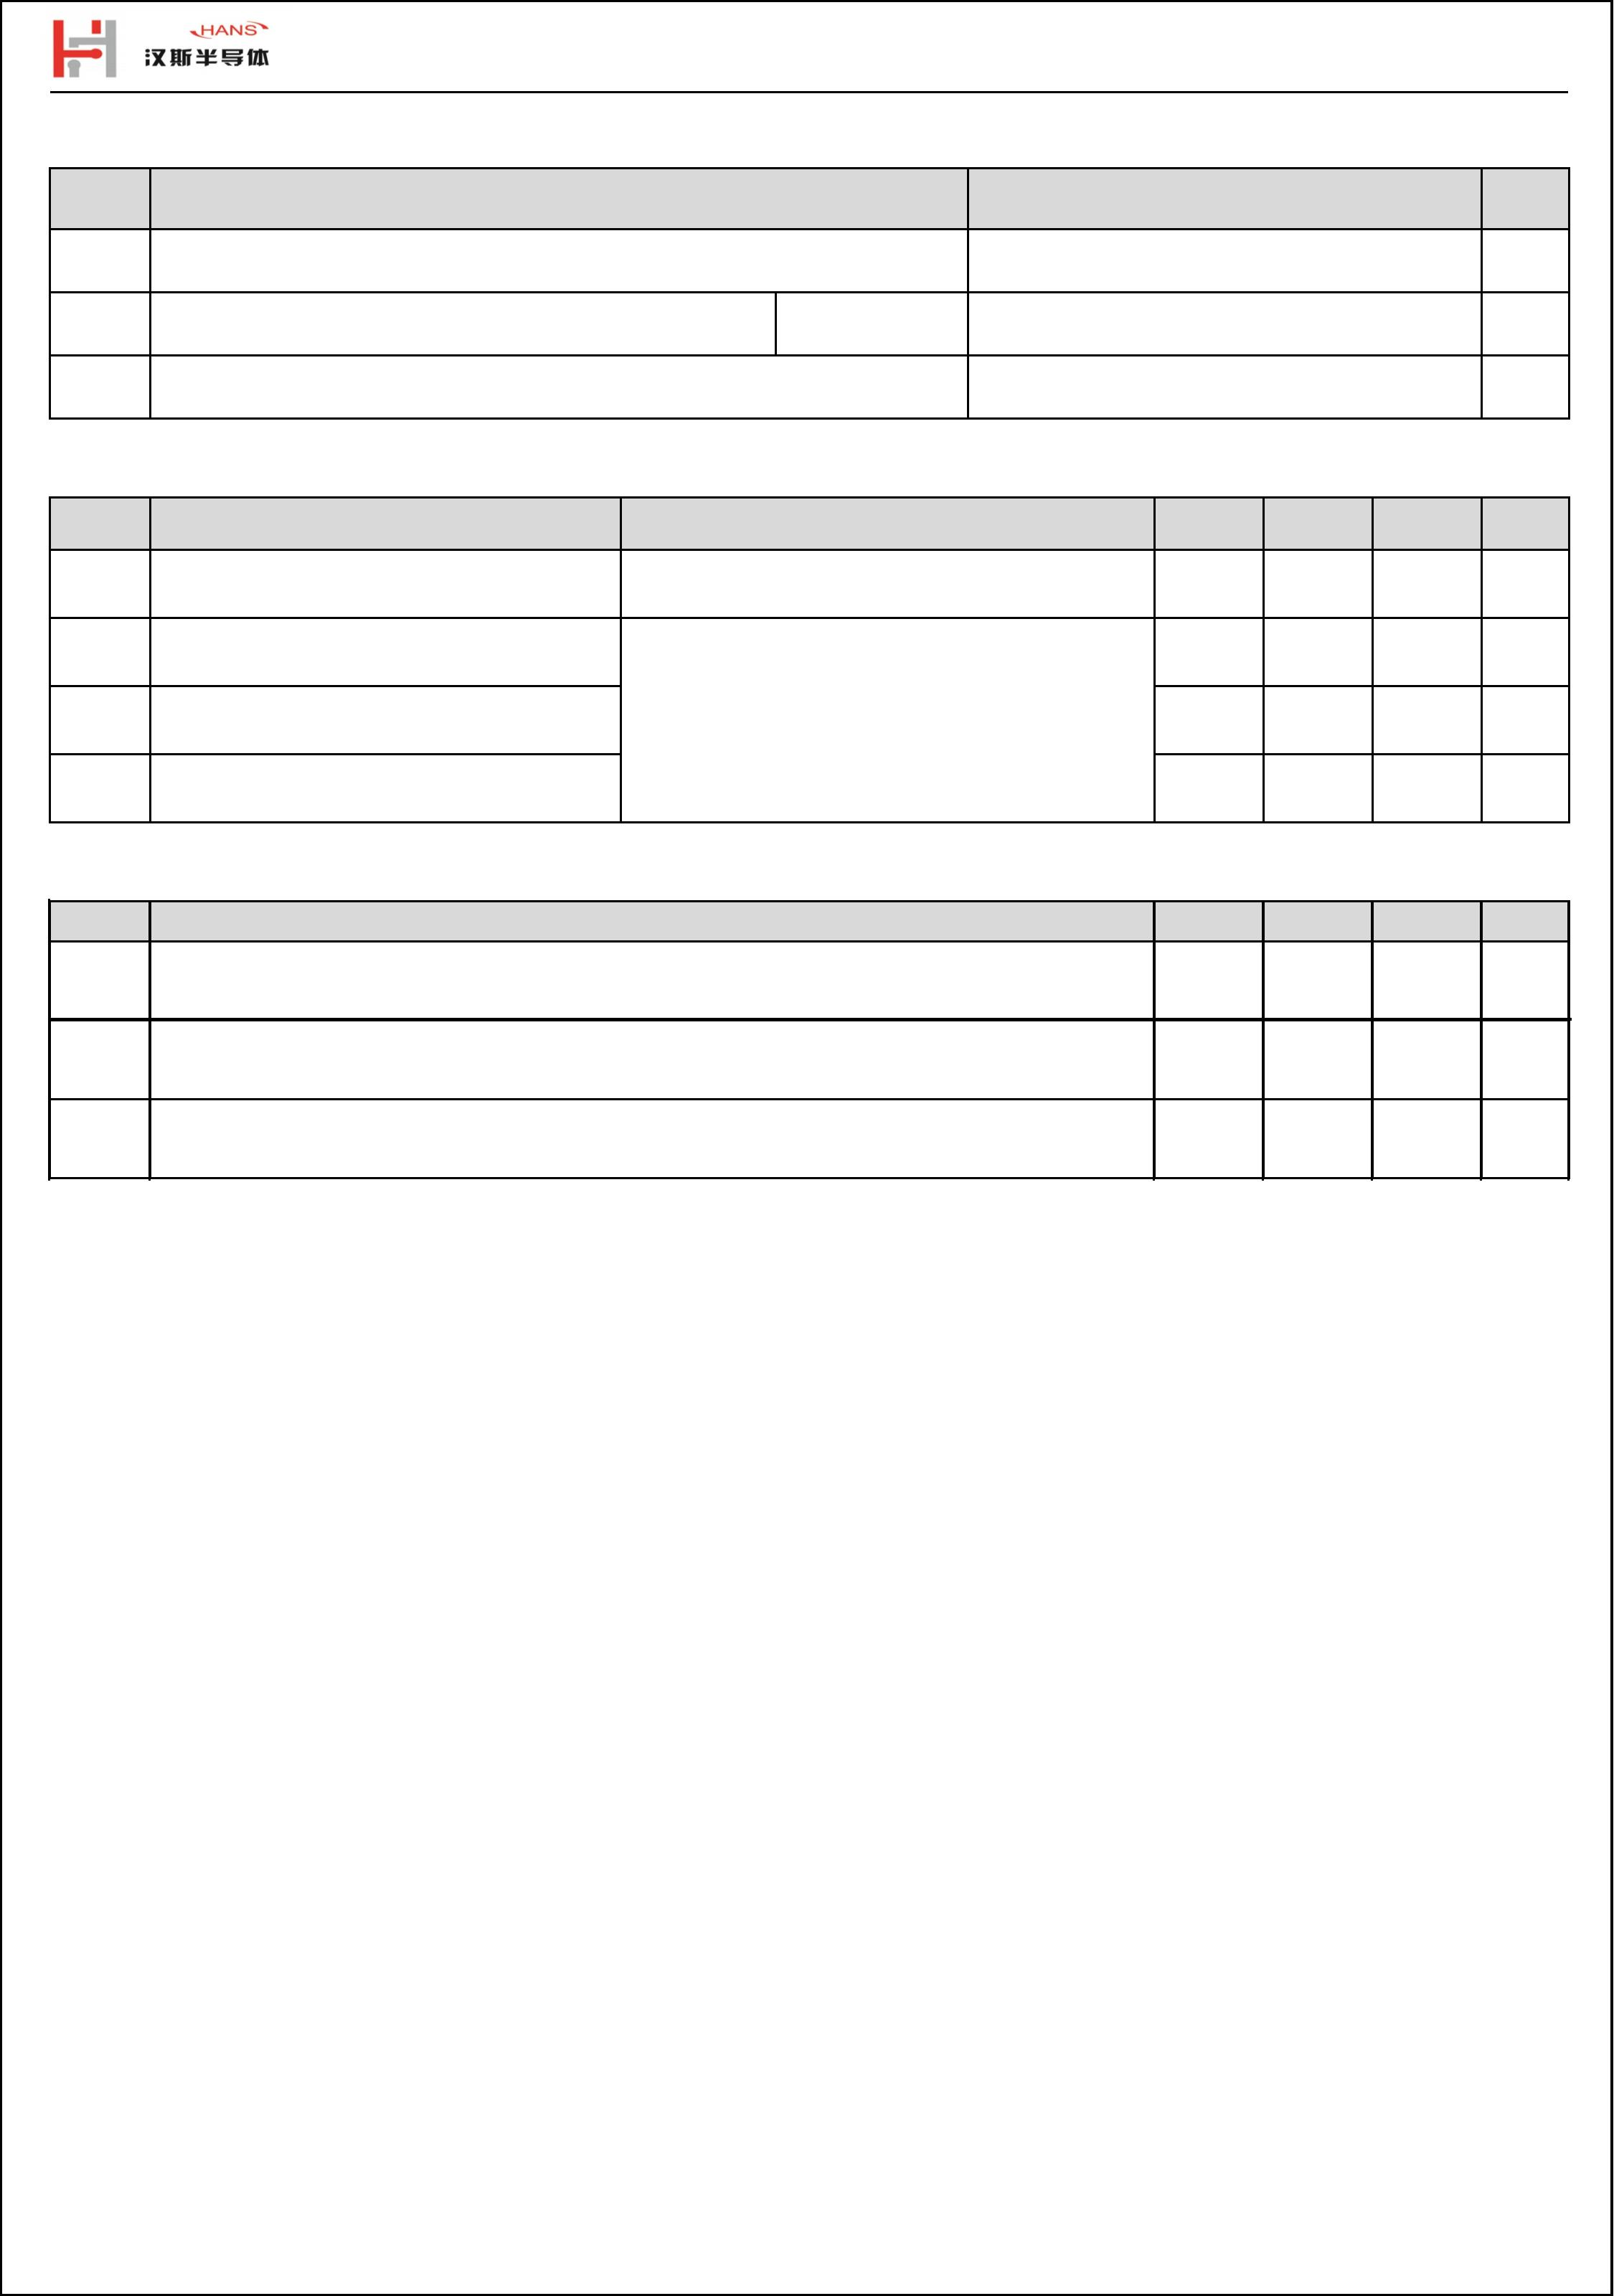

HSG15N120LJ

输出特性IGBT

传输特性IGBT

Typical output characteristic IGBT

I = f(V )

Tvj = 25 °C

Typical transfer characteristic IGBT

I = f(V )

C

CE

C

GE

Tvj = 25 C

°

V (V)

GE

V (V)

CE

电容

开关损耗IGBT

capacitance as a function of collector-emitter

voltage IGBT

output characteristic IGBT

Eon = f(R ) ,Eoff = f(R )

G

G

C = f(V ) ,f = 1MHz, V = 0 V

V =15V,I =15A,V =600V

CE

°

Tvj = 25 C

GE

GE

C

CE

V (V)

CE

R (Ω)

G

HansSemicon.cn

4

Preliminary Datasheet

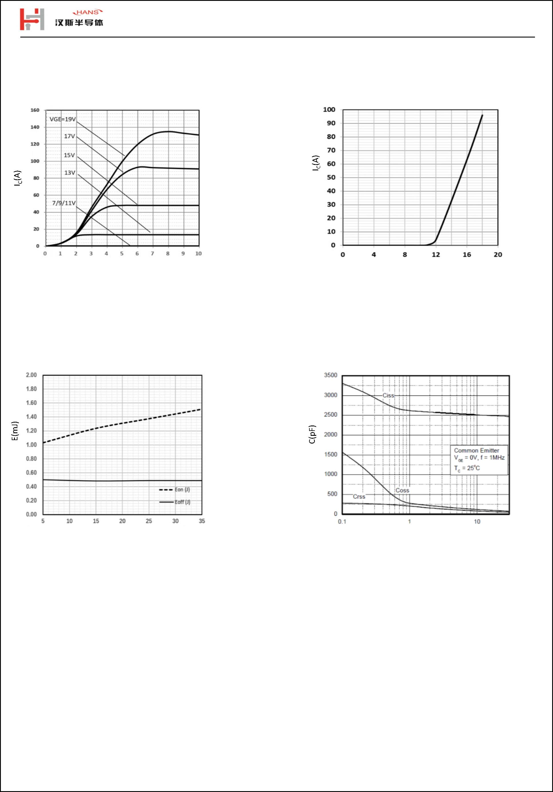

HSG15N120LJ

功耗

正向偏压二极管

Power dissipation as a function of case temperture

P =f(T )

Diode forward voltage as a function of

junction temperature

D

C

TC(℃)

TC(℃)

开关损耗二极管

瞬态热阻抗

Switching losses Diode

Err = f(di/dt)

normalized transient thermal impedance,iunction to case

ZthJC=f(t)

V =15V,I =15A,V =600V

GE

C

CE

di/dt(A/us)

t, Pulse Width (s)

HansSemicon.cn

5

Preliminary Datasheet

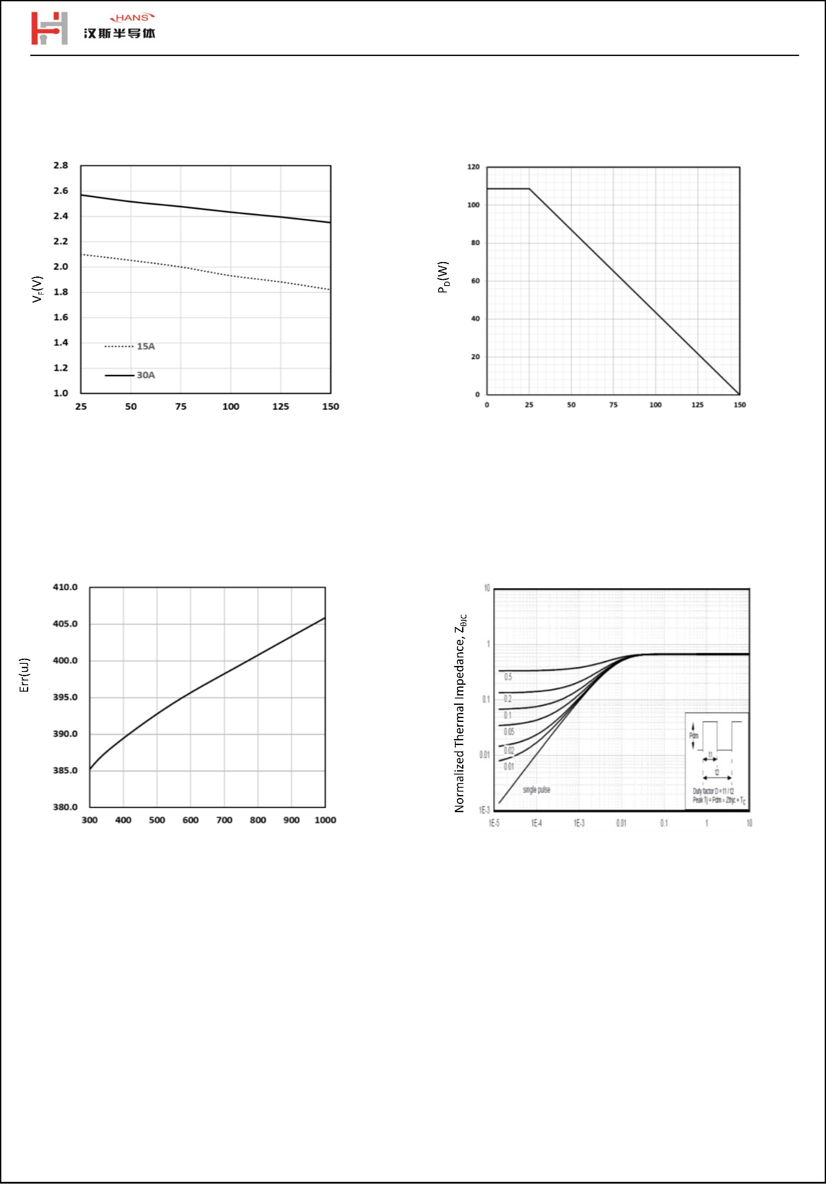

HSG15N120LJ

封装尺寸/package outlines

HansSemicon.cn

6

Preliminary Datasheet

