**IGBT**

# HSG40N120LJ

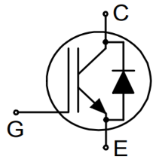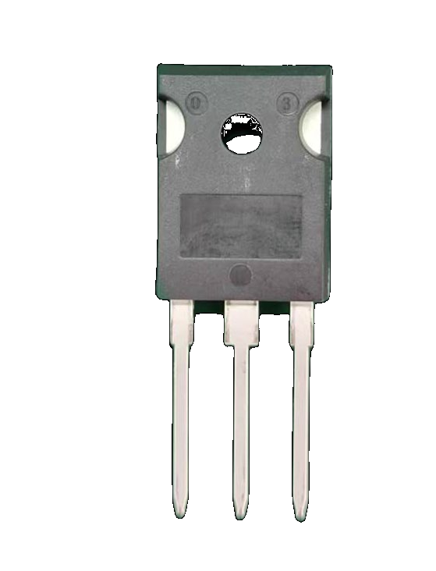

**Features/特性**

* 1200V，40A
* VCE(sat)(typ.)=2.1V @VGE=15V,IC=40A
* 具有正温度系数的VCE(sat)

VCE(sat) with positive temperature coefficient

* 包括快速软恢复反并联前馈

Including fast & soft recovery anti-parallel FWD

* 快开关速度

High speed switching

**Applications/应用**

* 不间断电源

Uninterruptible power supply

* 电机驱动逆变器

Inverter for motor drive

* 交、直流伺服驱动放大器

AC and DC servo drive amplifier

**Equivalent Circuit Schematic/等效电路图**

**IGBT-Absolute Maximum Ratings (@ TC = 25°C unless otherwise specified)**

# HSG40N120LJ



|  |  |  |  |  |
| --- | --- | --- | --- | --- |
| **Symbol** | **Parameter** | | **Value** | **Units** |
| VCES | Collector-Emitter Voltage  集电极-发射极电压 | | 1200 | V |
| VGES | Gate-Emitter Peak Voltage  栅极-发射极峰值电压 | | ±30 | V |
| IC | DC collector current, limited by Tvjmax  集电极直流电流受最大结温限制 | TC = 100°C | 40 |  |
| ICM | Pulsed collector current, tp limited by Tvjmax  集电极脉冲电流脉宽受最大结温限制 | | 90 | A |
| Ptot | Maximum Power Dissipation  最大耗散功率 | TC = 25°C | 300 | W |
| TC = 100°C | 110 | W |
| TJ | Operating Junction Temperature  工作结温 | | -55 to 150 | ℃ |
| TSTG | Storage Temperature Range  储存温度 | | -55 to 150 | ℃ |

**IGBT Characteristics (@ TC = 25°C unless otherwise specified)**

|  |  |  |  |  |  |  |
| --- | --- | --- | --- | --- | --- | --- |
| **Symbol** | **Parameter** | **Conditions** | **Min.** | **Typ.** | **Max.** | **Unit** |
| VCE sat | Collector to Emitter Saturation Voltage  集电极-发射极饱和电压 | IC = 40 A, VGE = 15 V |  | 2.1 |  | V |
| VGE th | Gate-Emitter Threshold Voltage  栅极阈值电压 | IC = 250 uA, VCE = VGE | 4.5 |  | 6.5 | V |
| ICES | Collector-Emitter Cut-off Current  集电极-发射机截止电流 | VCE = 1200 V, VGE = 0 V, Tvj = 25°C |  |  | 100.0 | uA |
| IGES | Gate-emitter Leakage Current  栅极-发射极漏电流 | VCE = 0 V, VGE = ±30 V, Tvj = 25°C |  |  | ±100 | nA |
| QG | Gate Charge  栅极电荷 | VCC=600V,IC=40A VGE=15V |  | 107 |  | nC |
| QGE | Gate-Emitter Charge  栅极-发射极电荷 |  | 36 |  | nC |
| QGC | Gate-Collector Charge  栅极-集电极电荷 |  | 58 |  | nC |
| Cies | Input Capacitance  输入电容 | VCE=25V,f=1MHz, VGE=0V |  | 3000 |  | nF |
| Coies | Output Capacitance  输出电容 |  | 80 |  | nF |
| Cres | Reverse Transfer Capacitance  反向传输电容 |  | 30 |  | nF |
| tdon | Turn-on Delay Time  开通延迟时间 | VCE=600V,IC=40A, RG=15Ω,VGE=15V |  | 87 |  | nS |
| tr | Rise Time  上升时间 |  | 231 |  | nS |
| tdoff | Turn-off Delay Time  关断延迟时间 |  | 158 |  | nS |
| tf | Fall Time  下降时间 |  | 138 |  | nS |
| Eon | Turn-On Switching Loss Per Pulse  开通损耗能量 |  | 6.1 |  | mJ |
| Eoff | Turn-off Energy Loss Per Pulse  关断损耗能量 |  | 2.1 |  | mJ |

**Diode-Absolute Maximum Ratings (@ TC = 25°C unless otherwise specified)**

# HSG40N120LJ



|  |  |  |  |  |
| --- | --- | --- | --- | --- |
| **Symbol** | **Parameter** | | **Value** | **Units** |
| VRRM | Repetitive Peak Reverse Voltage  反向重复峰值电压 | | 1200 | V |
| IF | Diode Continuous Forward Current  连续正向直流电流 | TC = 100°C | 40 |  |
| IFM | Diode maximum current, tp limited by Tvjmax  二极管最大电流，脉宽受最大结温限制 | | 90 | A |

**Diode Characteristics (@ TC = 25°C unless otherwise specified)**

|  |  |  |  |  |  |  |
| --- | --- | --- | --- | --- | --- | --- |
| **Symbol** | **Parameter** | **Conditions** | **Min.** | **Typ.** | **Max.** | **Unit** |
| VF | Diode Forward Voltage  正向电压 | IF = 40 A |  | 1.7 | 2.7 | V |
| Qrr | Recovered Charge  恢复电荷 | IF = 40A, VCE = 600 V,  dIF/dt=250A/us |  | 2840 |  | nC |
| Irr | Peak Reverse Recovery Current  反向恢复峰值电流 |  | 16 |  | A |
| trr | Reverse Recovery Time  反向恢复时间 |  | 326 |  | nS |

**Thermal Characteristics**

|  |  |  |  |  |  |
| --- | --- | --- | --- | --- | --- |
| **Symbol** | **Parameter** | **Min.** | **Typ.** | **Max.** | **Unit** |
| RthJC | Thermal resistance, junction to case for IGBT IGBT 结-外壳热阻 |  |  | 0.4 | ℃/W |
| RthJC | Thermal resistance, junction to case for Diode  二极管 结-外壳热阻 |  |  | 0.8 | ℃/W |
| RthJA | Thermal resistance, junction to Ambient  结-环境热阻 |  |  | 40 | ℃/W |

# HSG40N120LJ

输🎧特性IGBT

Typical output characteristic IGBT IC = f(VCE)

Tvj = 25 °C

传输特性IGBT

Typical transfer characteristic IGBT IC = f(VGE)

Tvj = 25 °C

IC(A)

IC(A)

VCE(V)

VGE(V)

开关损耗IGBT

output characteristic IGBT

Eon = f(RG) ,Eoff = f(RG) VGE=15V,IC=40A,VCE=600V

电容

capacitance as a function of collector-emitter voltage IGBT

C = f(VCE) ,f = 1MHz, VGE = 0 V Tvj = 25 °C

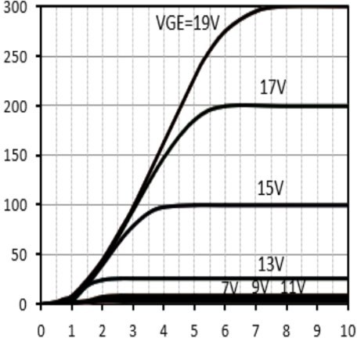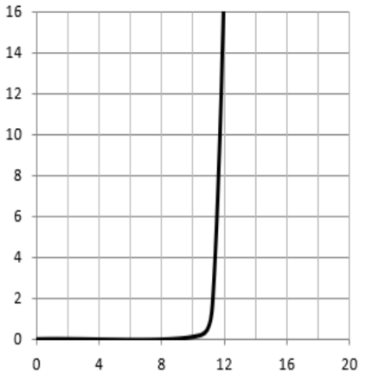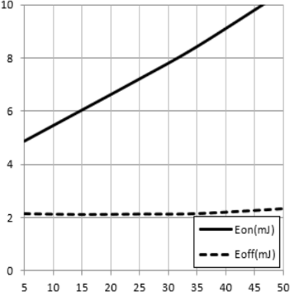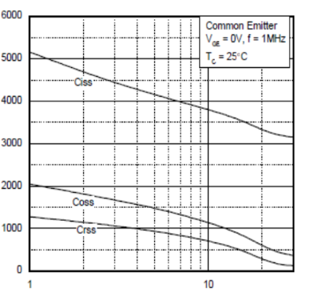

RG(Ω) VCE(V)

E(mJ)

C(pF)

# HSG40N120LJ

正向偏压二极管

Diode forward voltage as a function of junction temperature

PD(W)

功耗

Power dissipation as a function of case temperture PD=f(TC)

## TC(℃)

TC(℃)

开关损耗二极管 Switching losses Diode Err = f(di/dt)

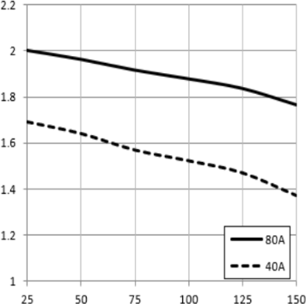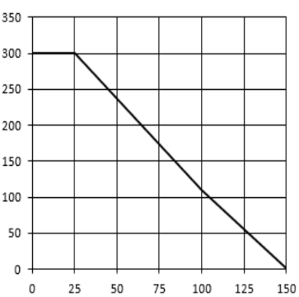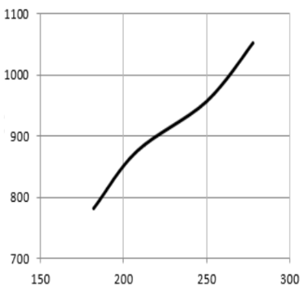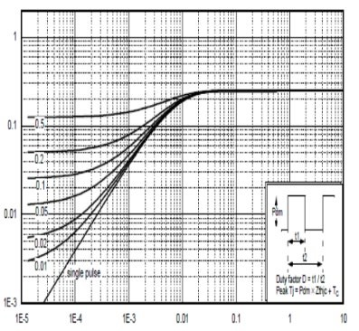

VF(V)

## VGE=15V,IC=40A,VCE=600V

Err(uJ)

di/dt(A/us)

瞬态热阻抗

normalized transient thermal impedance,iunction to case ZthJC=f(t)

Normalized Thermal Impedance, ZθJC

t, Pulse Width (s)

# HSG40N120LJ

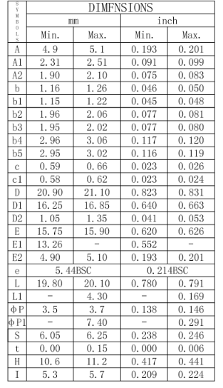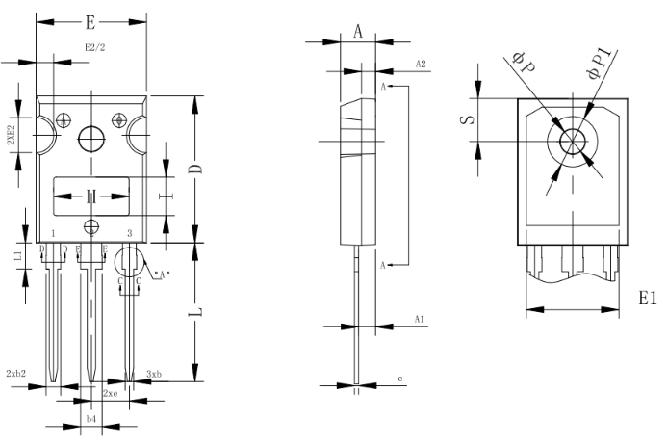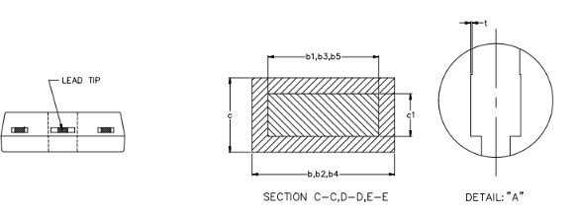

**封装尺寸/package outlines**